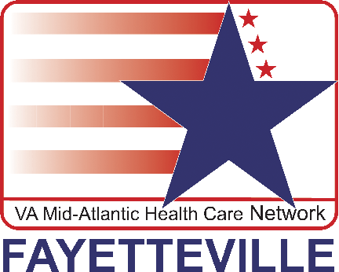
Department of
Veterans Affairs
Fayetteville VA Medical Center
Office of Public Affairs
2300 Ramsey Street
Fayetteville, N.C. 28301
News Release

FOR IMMEDIATE RELEASE
July 19, 2012

VA Expanding Health Care With Announcement of New Community-Based Clinic in
Lee County, NC
Veterans Get Increased Access to World-Class Health Care
Fayetteville, NC – The Secretary of Veterans Affairs Eric K. Shinseki’s announcement today of a new Community-Based Outpatient Clinic (CBOC) in Lee County continues the excitement at the Fayetteville VA Medical Center with expansion of additional CBOCs and Health Care Centers to reinforce commitment to providing access to high-quality care for Veterans.
“We are very pleased the VA elected to approve construction of a new CBOC in Lee County for our Veterans,” said James Galkowski, Fayetteville VAMC associate director of operations. “Our first priority will be to determine the best site location in Lee County to ensure our Veterans have better access to quality health care that is close to home. We will continue to provide additional information on the estimated project completion date on our web site and in future media releases. We look forward to continuing our dedication and commitment to serve our Veterans and ensure they receive the best medical and mental health care they have earned.”
The Fayetteville VAMC currently serves Veterans in 19 counties in Southeastern North Carolina and two counties in Northeastern South Carolina. Community Based Outpatient Clinics (CBOCs) are located in Jacksonville, Hamlet, Robeson, Brunswick and Wilmington, North Carolina serving more than 16,000 patients residing in those nearby counties. The CBOCs provide Veterans with Primary Care, Mental Health Care and offer tele-medicine for other specialized needs.
In addition to the new clinic in Lee county, new community clinics are also planned for:
Arizona – Northeast Phoenix/Maricopa
Georgia – Tifton/Tift
Kansas – Lenexa/Johnson County
Maryland – St. Mary’s
Missouri – Marshfield/Webster, Platte City/Platte, Springfield/Greene
Ohio – Georgetown/Brown
Oregon – Portland Metro South/Clackamas, Grants Pass/Josephine
Pennsylvania – Huntingdon, Indiana
For more information about VA’s health care services, please visit: http://www.va.gov/health/. For information about the Fayetteville VAMC, visit www.FayettevilleNC.VA.Gov.
# # #

